**Question 1: Please use Dijkstra’s algorithm to find the shortest paths from A to other nodes, and show the length of this paths. (Write out the solution process)**

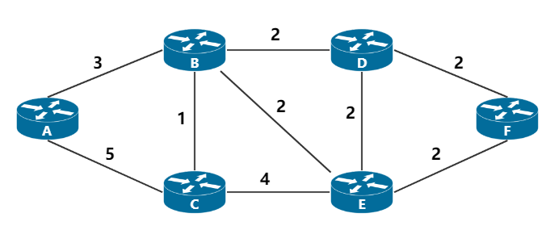

**Answer:**

|  |  |  |  |  |  |  |
| --- | --- | --- | --- | --- | --- | --- |
| **Step** | **N’** | **D(B),p(B)** | **D(C),p(C)** | **D(D), p(D)** | **D(E),p(E)** | **D(F),p(F)** |
| **1** | **A** | **3,A** | **5,A** | $$∞$$ | $$∞$$ | $$∞$$ |
| **2** | **AB** |  | **4,B** | **5,B** | **5,B** | $$∞$$ |
| **3** | **ABC** |  |  | **5,B** | **5,B** | $$∞$$ |
| **4** | **ABCD** |  |  |  | **5,B** | $$∞$$ |
| **5** | **ABCDE** |  |  |  |  | **7,E** |
| **6** | **ABCDEF** |  |  |  |  |  |

1. **>B length = 3**
2. **>B->C length = 4**

**A->B->D length = 5  
A->B->E length = 5**

**A->B->E->F length = 7**

**Question 2: Please use Dijkstra’s algorithm to find the shortest paths from D to other nodes, and show the length of these paths. (Write out the solution process)**

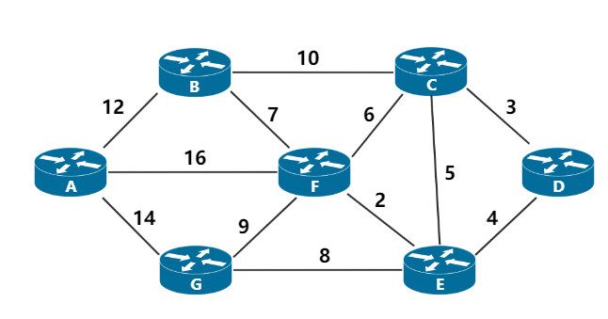

**Answer:**

|  |  |  |  |  |  |  |  |
| --- | --- | --- | --- | --- | --- | --- | --- |
| **Step** | **N’** | **D(A),p(A)** | **D(B),p(B)** | **D(C), p(C)** | **D(E),p(E)** | **D(F),p(F)** | **D(G),P(G)** |
| **1** | **D** | $$∞$$ | $$∞$$ | **3,D** | **4,D** | $$∞$$ | $$∞$$ |
| **2** | **DC** | $$∞$$ | **13,C** |  | **4,D** | **9,C** | $$∞$$ |
| **3** | **DCE** | $$∞$$ | **13,C** |  |  | **6,E** | **12,E** |
| **4** | **DCEF** | **22,F** | **13,C** |  |  |  | **12,E** |
| **5** | **DCEFG** | **22,F** | **13,C** |  |  |  |  |
| **6** | **DCEFGB** | **22,F** |  |  |  |  |  |
| **7** | **DCEFGBA** |  |  |  |  |  |  |

**D->C length = 3**

**D->E length = 4**

**D->E->F length = 6**

**D->E->G length = 12**

**D->C->B length = 13**

**D->E->F->A length = 22**

**Question 3: Please use Dijkstra’s algorithm to find the shortest paths from A to other nodes, and show the length of these paths. (Write out the solution process)**

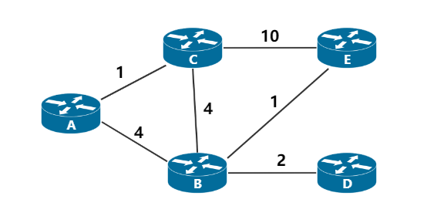

**Answer:**

|  |  |  |  |  |  |
| --- | --- | --- | --- | --- | --- |
| **Step** | **N’** | **D(B),p(B)** | **D(C),p(C)** | **D(D), p(D)** | **D(E),p(E)** |
| **1** | **A** | **4,A** | **1,A** | $$∞$$ | $$∞$$ |
| **2** | **AC** | **4,A** |  | $$∞$$ | **11,C** |
| **3** | **ACB** |  |  | **6,B** | **5,B** |
| **4** | **ACBD** |  |  |  | **5,B** |
| **5** | **ACBDE** |  |  |  |  |

**A->B length = 4**

1. **>C length = 1**
2. **>B->D length = 6**
3. **>B->E length = 5**

**Question 4: Please use Dijkstra’s algorithm to find the shortest paths from A to other nodes, and show the length of these paths. (Write out the solution process)**

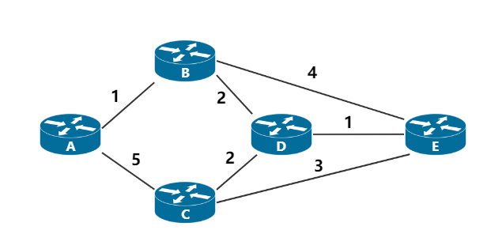

**Answer:**

|  |  |  |  |  |  |
| --- | --- | --- | --- | --- | --- |
| **Step** | **N’** | **D(B),p(B)** | **D(C),p(C)** | **D(D), p(D)** | **D(E),p(E)** |
| **1** | **A** | **1,A** | **5,A** | $$∞$$ | $$∞$$ |
| **2** | **AB** |  | **5,A** | **3,B** | **5,B** |
| **3** | **ABC** |  |  | **3,B** | **5,B** |
| **4** | **ACBD** |  |  |  | **4,D** |
| **5** | **ACBDE** |  |  |  |  |

**A -> B length = 1**

**A -> C length = 5**

**A -> B -> D length = 3**

**A -> B -> D -> E length = 4**

**Question 5: Please use distance vector algorithm to find the shortest paths from A to other nodes, and show the length of these paths. (Write out the solution process)**

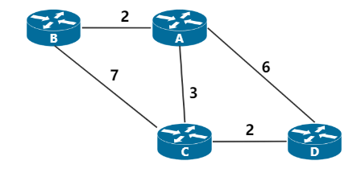

**Answer:**

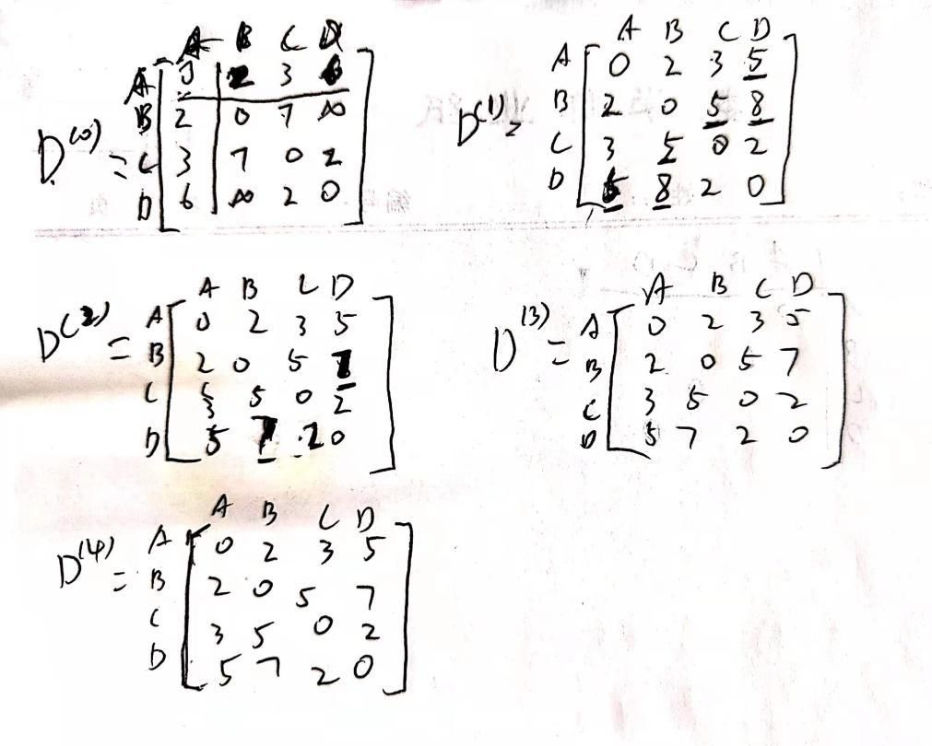

**A -> B length = 2**

**A -> C length = 3**

**A -> C -> D length = 5**

**Question 6: Please use distance vector algorithm to find the shortest paths from A to other nodes, and show the length of these paths. (Write out the solution process)**

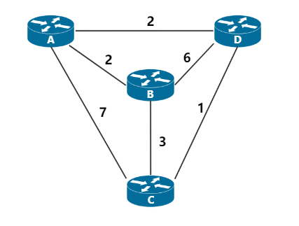

**Answer:**

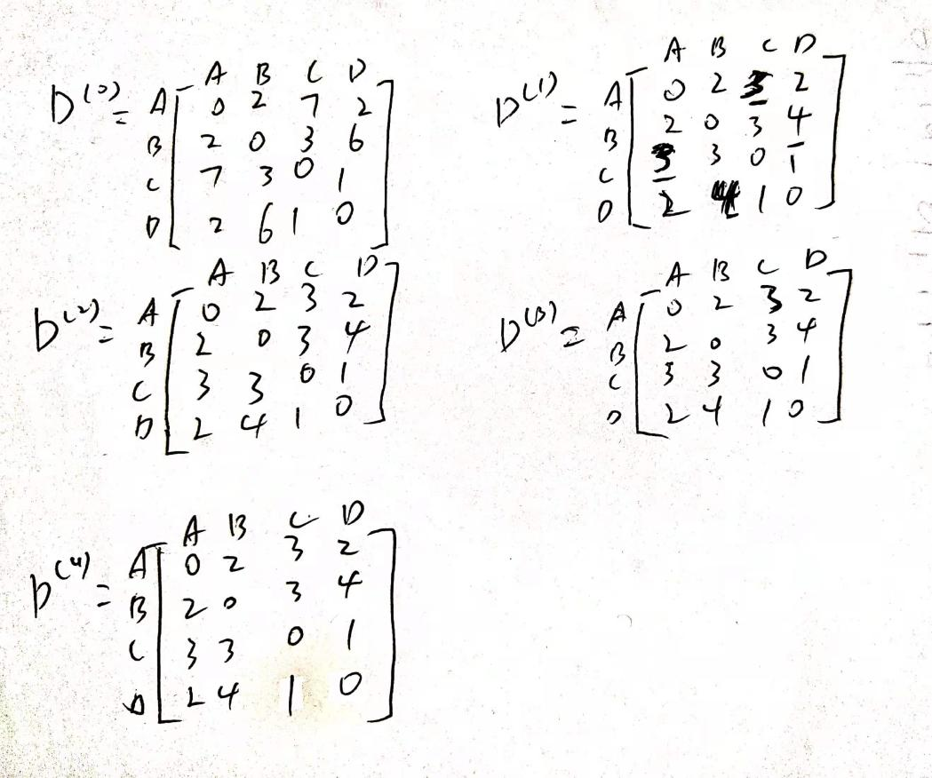

**A -> B length = 2**

**A -> D -> C length = 3**

**A -> D length = 2**

**Question 7: In the process of data transmission, if the binary bit sequence received by the receiver is 10110011010, and the generator polynomial used by both receivers is $G(x)=x^{4}$ + $x^{3}$ + 1, is there an error in the binary bit sequence during transmission? If there is no error, what are the bit sequence of the transmitted data and the bit sequence of the CRC check code?**

**Answer:**

**根据题意，生成多项式G(x)对应的二进制比特序列为11001。进行如下的二进制模2除法，被除数为10110011010，除数为11001：**

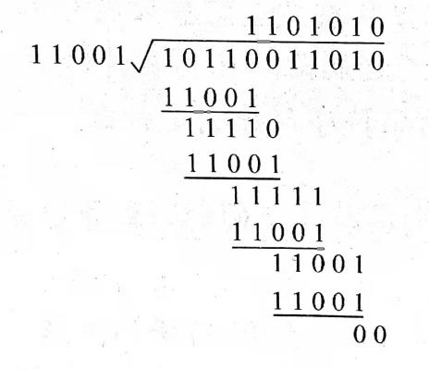

**所得余数为0，因此该二进制比特序列在传输过程中未出现差错。发送数据的比特序列为1011001，CRC检验码的比特序列为1010**

**Question 8: In the process of data transmission, if the data to be transmitted M=101001, and the generator polynomial used by the receivers is $G(x)=x^{3}$ + $x^{2}$ + 1, what is the data to be transmitted?**

**Answer:**

**根据题意，生成多项式对应的二进制比特序列为1101，多项式最高指数为3，即 $r$ = 3。待传输数据为M = 101001。因此，进行如下的二进制模2除法，被除数为101001000，除数为1101：**

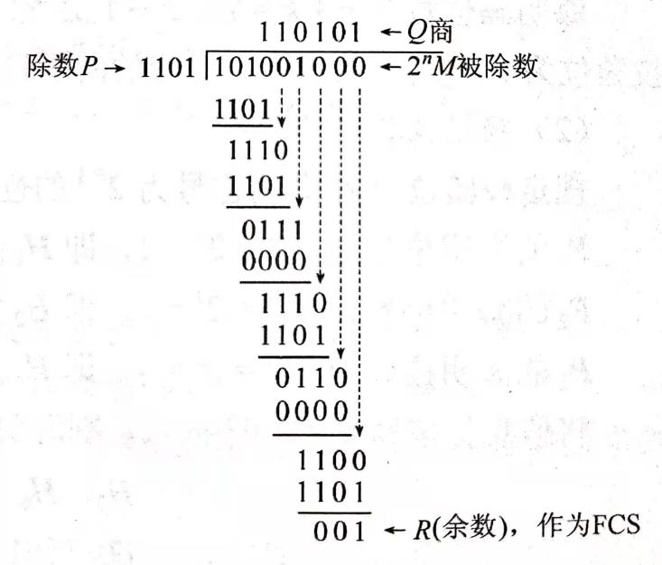

**所得余数R = 001，作为FCS。所以发送出去数据为101001001（$2^{r}M+FCS$）**